Financial Lit Name: _______________________

______________ _____________

WS Assessment

Target 6:

banking

**I can:**

* Understand how checking account work
* Reconcile a checking account with a bank statement by hand and by using a spreadsheet
* Learn the basic vocabulary of savings accounts.

**Unit 3 Math Topics:**

* Exponential functions
* Exponential base (*e*)
* Exponential growth and decay
* Formulas
* Linear equations and inequalities
* Limits
* Order of operations
* Recursive and iterative thinking: patterns, growth, decline, compound interest

A **checking account** is an account at a bank that allows a customer to deposit money, make

withdrawals, and make transfers from the funds on deposit. Payments can be made by writing a paper check or by making an electronic funds transfer (EFT). If a check is written for an amount that cannot be paid out of the account, the check is returned, or dishonored. This means that there **are insufficient funds** in the account and the payee will not receive the money. Banks charge a fee for processing returned checks. Some banks offer customers **overdraft protection** plans that pay a check even

though there are not enough funds in the account. There is a fee for this service and the money must be repaid. Some banks offer free checking while others have accounts that have a monthly maintenance fee. Some banks pay interest on their checking accounts, which is a percentage of the money that is in

the account over a given period of time.

Allison currently has a balance of $2,300 in her checking account. She deposits a $425.33 paycheck, a $20 rebate check, and a personal check for $550 into her checking account. She wants to receive $200 in cash. How much will she have in her account after the transaction?

Lizzy has a total of **x** dollars in her checking account. She makes a deposit of **b** dollar in cash and two checks each worth **c** dollars. She would like **d** dollars in cash from this transaction. She has enough

to cover the cash received in her account. Express her new checking account balance after the transaction as an algebraic expression.

A **check register** is a list of transactions in your bank account, along with a running balance that tells you how much money you have ​available to spend.

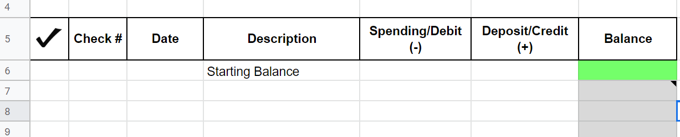

Create a check register for the transactions listed. (google docs for stamp)

There is a $2.25 fee for each ATM use.

a. Your balance on 10/29 is $237.47

b. You write check 115 on 10/29 for $18.00 to Fox High School.

c. You deposit a paycheck for $162.75 on 10/30.

d. You deposit a $25 check for your birthday on 11/4.

e. On 11/5, you go to a sporting event and run out of money. You use the ATM in the lobby to get $15 for snacks.

f. Your credit card bill is due on 11/10, so on 11/7 you write check 116 to Credit USA for $51.16.

g. Your sister repays you $20 on 11/10. You deposit it.

h. You withdraw $25 from the ATM to buy flowers on 11/12.

i. You deposit your paycheck for $165.65 on 11/16.

j. Your deposit a late birthday check for $35 on 11/17.

A customer keeps a record of all transactions concerning a checking account in a paper or electronic check register. The bank also keeps a record of all transactions. Every month, the bank makes available a **statement** listing all of the transactions and balances for the account. Whether using paper or electronic statements, you should verify the bank’s records to make sure no mistakes have been made. This process is called **balancing** a checkbook or **reconciling** a bank statement.

Compare a check register and bank statement, then perform the reconciling steps

Notes: Check with mark a ✓ appeared in previous month statement



Check register balance: $641.13 Statement ending balance: $628.24 Total deposits outstanding

Total withdrawals outstanding

Revised statement balance

A **savings account** is an account in which the bank pays interest for the use of the money deposited in the account. The money on deposit with a bank is used by the bank to give loans. The people who borrow the money from a bank must pay it back with interest. The interest they pay is greater than the interest the bank pays for use of a customer’s money. This way, the bank is able to pay depositors interest and still make a profit.

Raoul’s savings account must have at least $500, or he is charged a $4 fee. His balance was $716.23, when he withdrew $225. What was his balance?

Mae has $891 in her account. A $7 fee is charged each month the balance is below $750. She withdraws $315. If she makes no deposits or withdrawals for the next x months, express her balance algebraically.

Mitchell deposits $1,200 in an account that pays 4.5% simple interest. He keeps the money in the account for three years without any deposits or withdrawals. How much is in the account after three years?

How much principal must be deposited to earn $1,000 simple interest in 2 years at a rate of 5%?

How much principal must be deposited in a two-year simple interest account that pays 3¼ % interest to earn $300 in interest?

Derek has a bank account that pays 4.1% simple interest. The balance is $910. When will the account grow to $1,000?

How long will it take $10,000 to double at 11% simple interest?

Kerry invests $5,000 in a simple interest account for 5 years. What interest rate must the account pay so there is $6,000 at the end of 5 years?

Marcos deposited $500 into a 2.5-year simple interest account. He wants to earn $200 interest. What interest rate must the account pay?

Use the simple interest formula to find the missing entries (a 🡪 h) in the table. Round monetary amounts to the nearest cent.



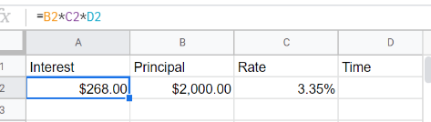Redo this problem using google docs for stamp (use formula as missing entries)

**Assessment Target 6**

**I can…** reconcile a checking account with a bank statement by hand and by using a spreadsheet

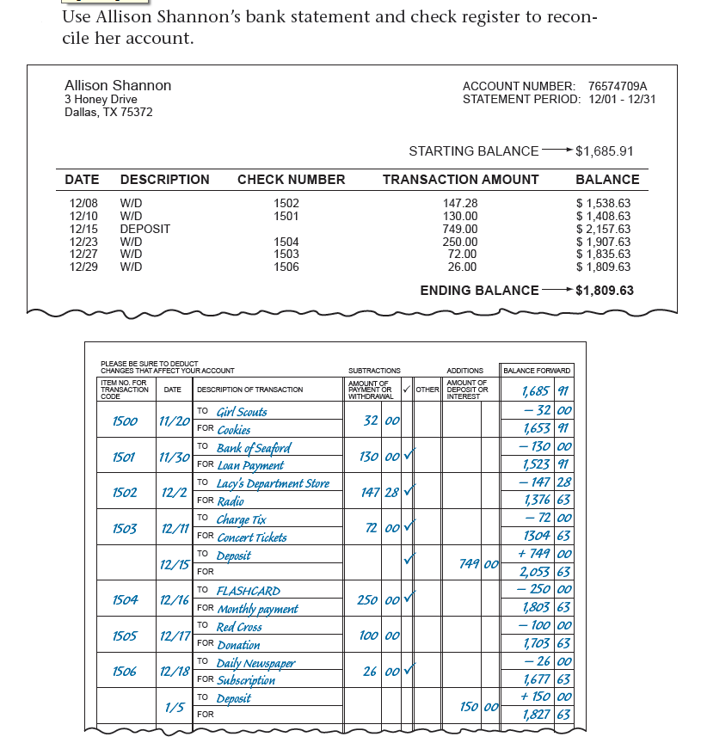

Check register balance: $

Statement ending balance: $ Total deposits

outstanding

Total withdrawals

outstanding

Revised statement balance

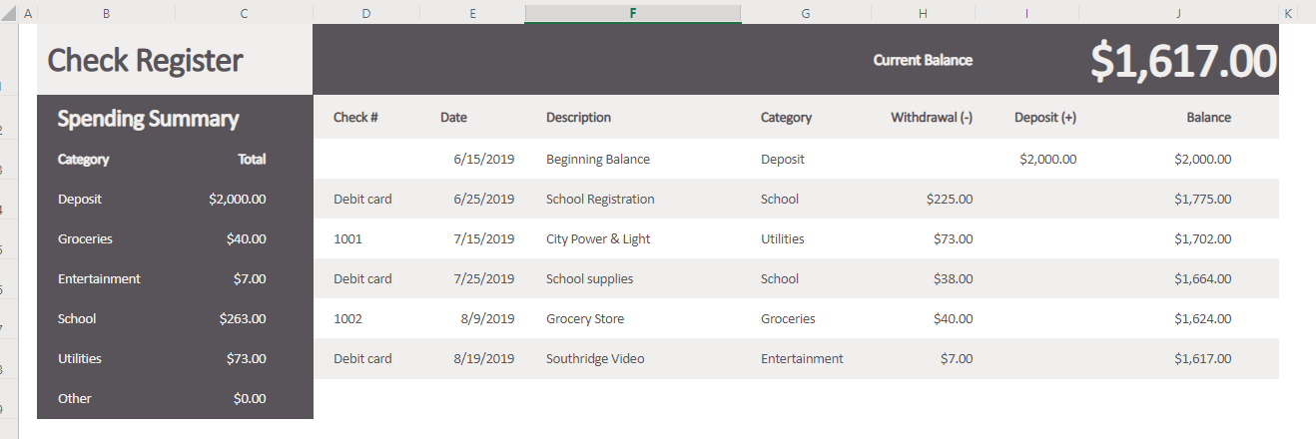Recreate the following Check Register in google docs for stamp

(Balance and Total Column are using formula)

How long does it take $450 to double at a simple interest rate of 14%?

What interest rate is needed for $9,500 to earn $900 in 19 months?